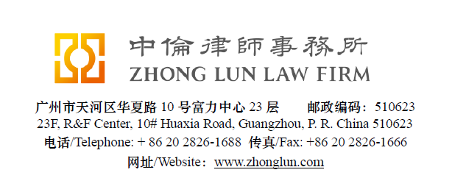

Invoice / 收款通知书

Date  日期 | 28/07/2019 | ZL Invoice Reference  中伦收款通知编号 |  | 052439-0001/012
Client  客户 |  | Tadmor & Co. Yuval Levy & Co.,  Attn: Ziv Wassercug  132 Begin Road  5 Azrieli Center, the Square Tower, 34th Floor  Tel Aviv 6701101, Israel
Subject Matter  事项 |  | Service Period  服务期限 | June 2019
Legal Fee  律师费 | USD 2,000 | Reimbursement  报销费用
Sum Now Due  总应付款 | USD 2,000

Please make the payment to the banks account as follows:
请将上述款项付至下列账户：

Account Number  账号 | 1209 0403 9310 502 | Swift Code  银行代码 | CMBCCNBS131
Account Name  账户名称 | Beijing Zhong Lun Law Firm Guangzhou Office  北京市中伦（广州）律师事务所
Bank Name  开户行 | China Merchants Bank, Guangzhou Branch, R&F Center Subbranch  招商银行广州分行富力中心支行
Address  地址 | 2/28F R&F Center, 10 Huaxia Road, Guangzhou, China  广州市华夏路10号富力中心2/28楼

Zhong Lun Law Firm 中伦律师事务所

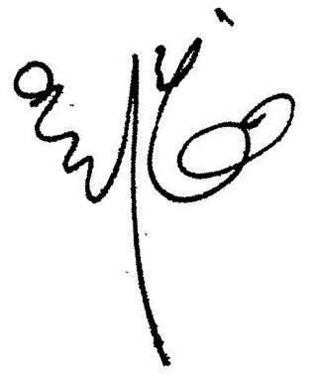


Charge Details / 收费明细

To our Professional Charges for our service rendered in respect of the following:
中伦律师事务所就如下事宜提供了专业服务：

Date  日期 | Description of Services  服务记录 | Personnel  人员 | Hours Spent  所用小时数
11/06/19 | Reviewing the Legal Opinion on SASAC prepared by Helen WONG and sending he draft to Ziv. | Kent W | 3.0
 | Preparing the Legal Opinion on SASAC. | Helen W | 4.4
24/06/19 | Proofreading the Legal Opinion on the SASAC. | Helen W | 0.3

For clarification we have set out below a table showing the hours spent by ZL personnel:
为明确起见，我们在下表中列明了中伦律师事务所工作人员所花费的时间：

Personnel  人员 | Hours Spent  总计小时数 | Rate (USD)/hour  每小时费率 | Legal Fee (USD)  律师费
Kent WOO | 3.0 | 480 | 1,440
Helen WONG | 4.7 | 280 | 1,316
 |  | Totals/合计: | 2,756
 |  | Capped: | 2,000

Please kindly indicate the ZL Invoice Reference number on your bank processing document and provide us a copy of the bank confirmation for the payment. /请在银行付款单据上标明中伦收款通知编号，并向我方提供相关银行确认书。
Please pay equivalent foreign currency if an USD account is not available. /若未能支付美元，请支付等值外币。
Please indicate the FULL name in the bank advice and state the FULL name at the remark or note section on the bank advice./ 请在银行付款单据上列明全称并在汇款附言或备注栏填入收款人全称。

